


Predictive Modeling for Sales Forecasting and Optimization in the European Bicycle Retail Market

Graduation Project Thesis Submitted to Digital Egypt Generations (DEG)

CLS ONL3_AIS4_G1

2025

Predictive Modeling for Sales Forecasting and Optimization in the European Bicycle Retail Market

By
Adham Sameh Ayoub
Ahmed Khaled Hamed
Mennatullah Ayman Gamal
Mohamed Abdelhakim Sallam
Mohamed Atef Saadeldin
Mohammed Gamal Mostafa
Sara Gamal Ramadan

Abstract
This thesis, titled Predictive Modeling for Sales Forecasting and Optimization in the European Bicycle Retail Market, addresses the critical need for data-driven decision-making within the bicycle retail sector. The project utilized a dataset of 112,366 cleaned historical transactions spanning 2011 to 2016 across six countries and 53 regions.
The methodology involved comprehensive Data Quality Assessment and Correction, including the removal of 1,000 duplicate records and rigorous Feature Engineering to create variables such as Season and Profit_Margin.

Acknowledgement
We wish to express our sincere gratitude to everyone who contributed to the successful completion of this graduation project, "Predictive Modeling for Sales Forecasting and Optimization in the European Bicycle Retail Market".
Our deepest thanks go to our dedicated mentors at Digital Egypt Generations (DEG) and the National Telecommunication Institute (NTI) for their expert guidance, invaluable technical support, and continuous encouragement throughout this process.

1. Dataset Overview
1.1 Data Source & Collection
Collection method: The dataset was collected by web scraping publicly accessible product and transaction pages from an online shopping site. The scraping process compiled historical transaction and listing records that together cover the period 2011–2016.
What was scraped: The extraction gathered structured information corresponding to the dataset columns used in this analysis, including date components (day, month, year), Product information (category, sub-category, product name), transactional values (order quantity, unit cost, unit price), and limited customer attributes (age range, gender) where provided on listings or associated order records.
1.2 Scope
- Time Period: 2011–2016 (6 years)
- Geographic Coverage: 6 countries, 53 states/regions
- Product Range: 3 main categories (bicycles, Accessories, Clothing)
- Original Dataset Size: 113,366 transactions
- Final Dataset Size: 112,366 transactions (after cleaning)

1.3 Data Structure
The dataset contains 18 columns covering four main dimensions:
Temporal Information:
● Date, Day, Month, Year
● Calculated Date (engineered)
● Season (engineered)
Customer Demographics:
● Customer Age (17-87 years)
● Age Group (Youth, Young Adults, Adults, Seniors)
● Customer Gender (M/F)
Geographic Information:
● Country (6 countries)
● State (53 states/regions)

Product Information:
● Product Category, Sub Category, Product
● Order Quantity, Unit Cost, Unit Price
Financial Metrics:
● Cost, Revenue, Profit
● Profit Margin (engineered)

2. Data Quality Assessment & Corrections

2.1 Data Quality Issues Identified

2.1.1 Duplicate Records
- Issue: 1,000 duplicate transactions detected
- Impact: 0.88% of total records
- Detection Method: data.duplicated().sum()
- Correction: Complete duplicate removal using drop_duplicates()
- Result: Dataset reduced from 113,366 to 112,366 records

2.1.2 Data Type Inconsistencies
- Issue: Suboptimal data types for analysis
- Corrections Made:
  - Categorical columns converted to 'category' dtype for memory efficiency
  - Financial columns standardized to float type
  - Date column properly formatted as datetime

2.1.3 Date Column Redundancy
- Issue: Both 'Date' and component columns (Year, Month, Day) present
- Validation: Cross-verification showed 100% consistency between Date and calculated date
- Correction:
  - Created 'Calculated_Date' from components
  - Validated consistency: (data['Date'] == data['Calculated_Date']).all() returned True
  - Removed original 'Date' column to eliminate redundancy

2.2 Missing Data Analysis
- Result: Zero missing values detected across all columns
- Verification: data.isnull().sum() returned 0 for all columns
- Assessment: Exceptional data completeness (100%)

3. Feature Engineering

3.1 Seasonal Classification
- New Feature: Season
- Logic:
- Winter: December, January, February
- Spring: March, April, May
- Summer: June, July, August
- Autumn: September, October, November

- Purpose: Enable seasonal trend analysis
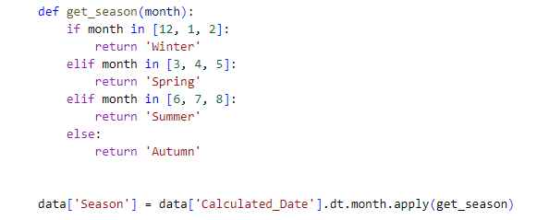

3.2 Profit Margin Calculation
- New Feature: Profit_Margin
- Formula: (Profit ÷ Revenue) × 100
- Purpose: Standardized profitability comparison across products and categories
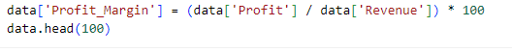

4. Correlation Heatmap
The heatmap shows how Revenue relates to other numeric variables (Order_Quantity, Unit_Cost, Unit_Price, Profit).

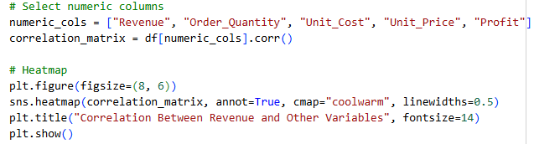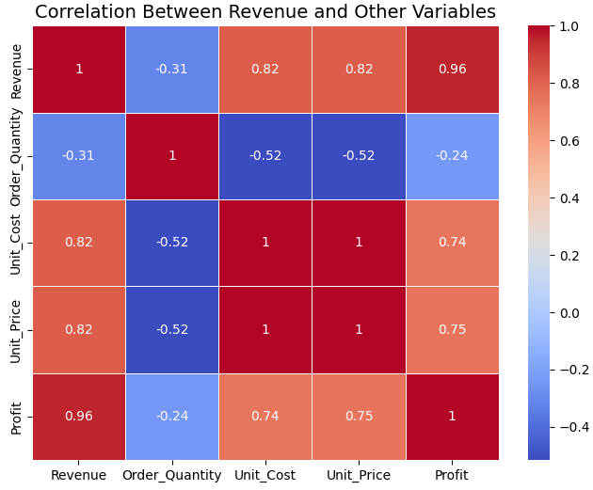

5. Exploratory Data Analysis Findings

5.1 Customer Demographics Analysis

5.1.1 Age Distribution
- Age Range: 17-87 years
- Distribution: Normal distribution with slight right skew
- Key Insight: Broad customer base spanning all adult age groups
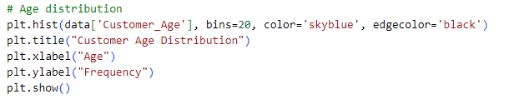
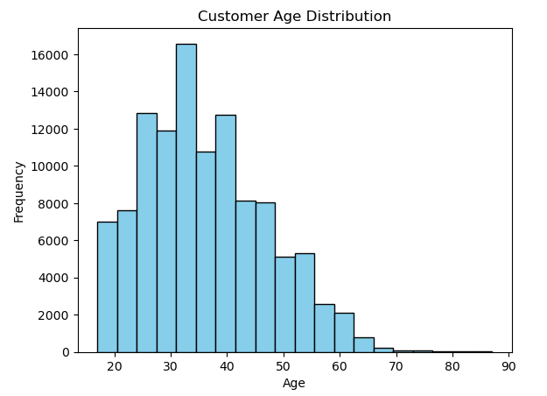

5.1.2 Gender Analysis
- Male Customers: Slightly higher representation
- Female Customers: Strong presence in the customer base
- Revenue Distribution: Relatively balanced between genders
- Business Implication: Gender-neutral marketing strategies appear effective
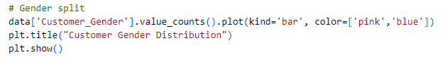
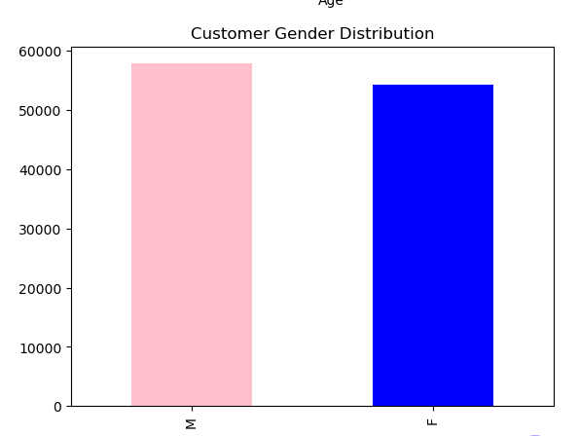

5.1.3 Age Group Performance
- Adults (35-64): Highest revenue contributors
- Young Adults (25-34): Second highest revenue segment
- Youth (<25): Moderate contribution
- Seniors (65+): Smallest but valuable segment
- Strategic Insight: Focus marketing efforts on Adults and Young Adults while maintaining engagement with other segments
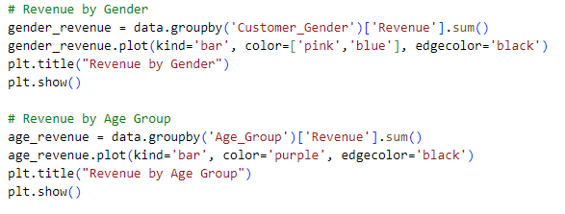
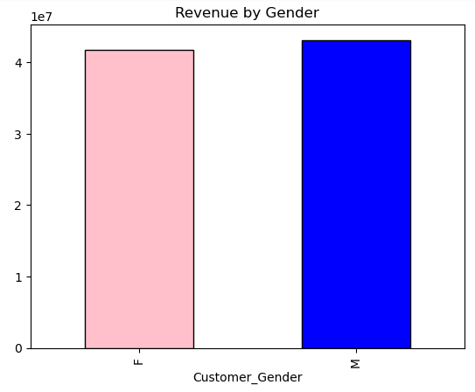
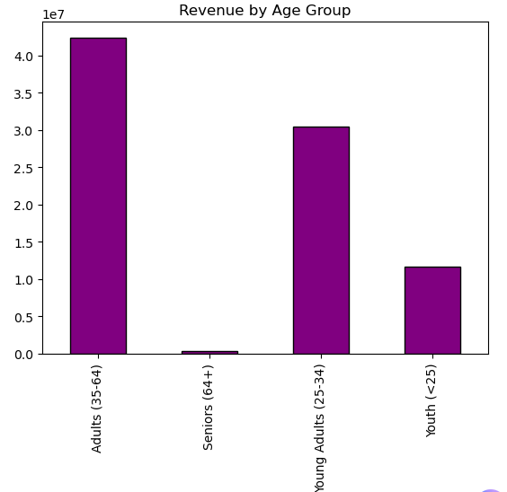
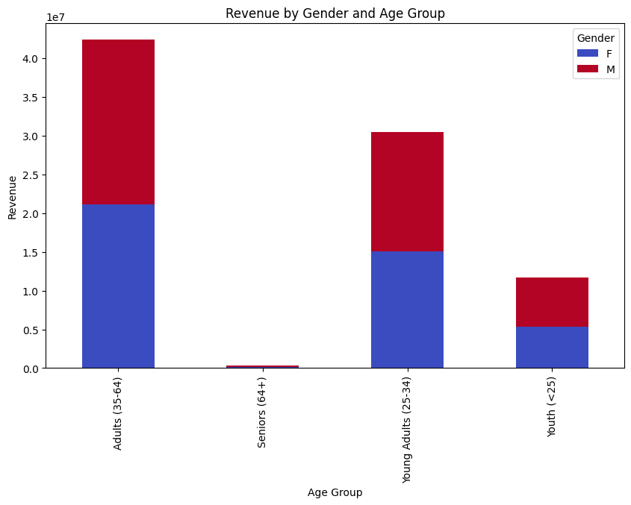

5.2 Temporal Trends Analysis

5.2 Monthly Revenue Patterns
- Trend: Clear seasonal patterns observed
- Peak Periods: Summer months show higher sales
- Low Periods: Winter months demonstrate reduced activity
- Business Application: Seasonal inventory planning and marketing campaigns
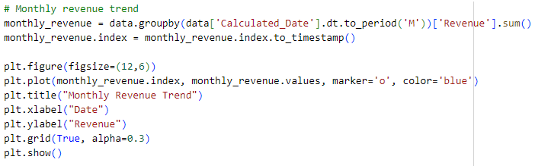
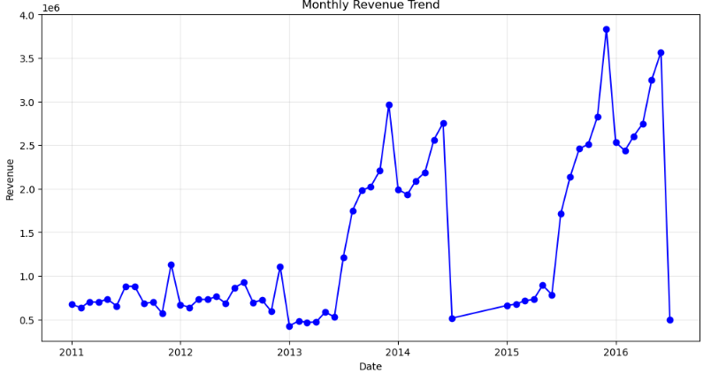

5.3 Geographic Performance Analysis

5.3.1 Country-Level Revenue
- Top Performers: United States, Australia, Canada
- Moderate Performers: Germany, France
- Developing Markets: United Kingdom
- Strategic Insight: North American markets show strongest performance
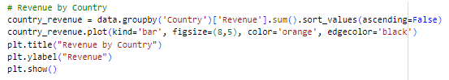
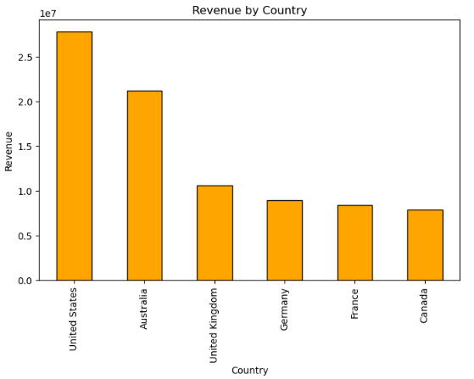

5.4 Product Performance Analysis

5.4.1 Category Revenue Analysis
- Bikes: Dominant category driving majority of revenue
- Accessories: Secondary revenue contributor
- Clothing: Smallest but consistent revenue stream
- Profitability: Bikes show highest absolute profit but varying margins

5.4.2 Top Performing Products
- Mountain Bikes: Strong performers in profit generation
- Road Bikes: Consistent high-profit products
- Product Concentration: Top 10 products contribute significantly to overall profit
- Inventory Focus: High-performing product lines identified for prioritization
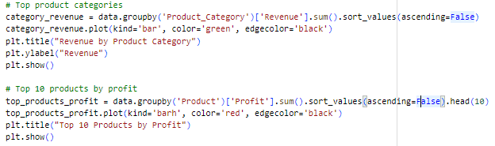

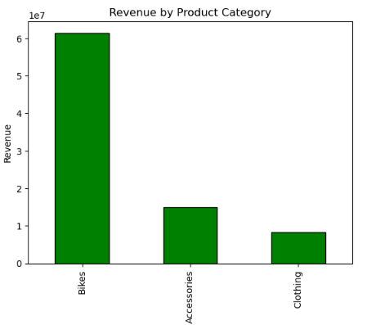

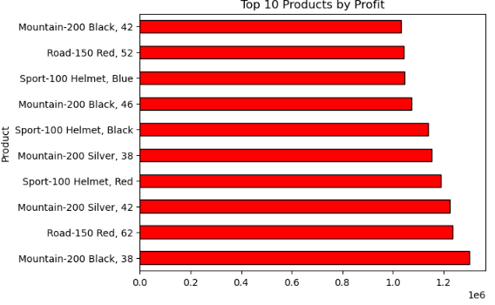

5.5 Profit Margin Distribution
- Distribution: Wide range of profit margins across products
- Average Margin: Healthy profitability indicators
- Outliers: Some products with exceptional margins identified
- Opportunity: Margin optimization potential across product lines
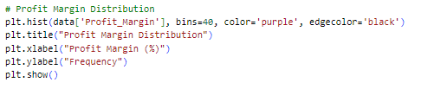
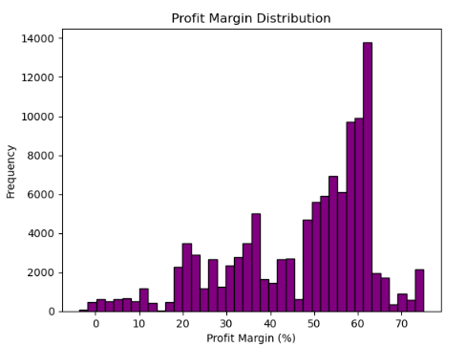

6. Combined Comparison
- Between all the above variables (Age_Gender_Country_Product).
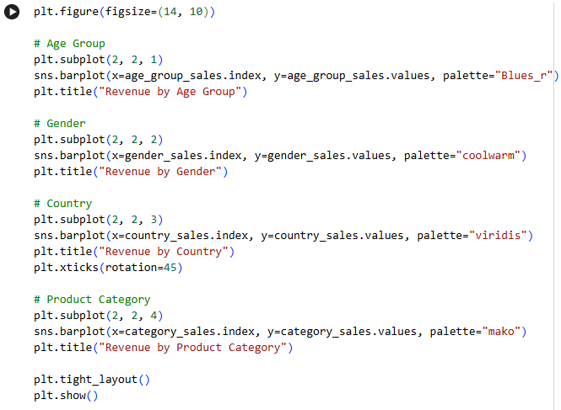
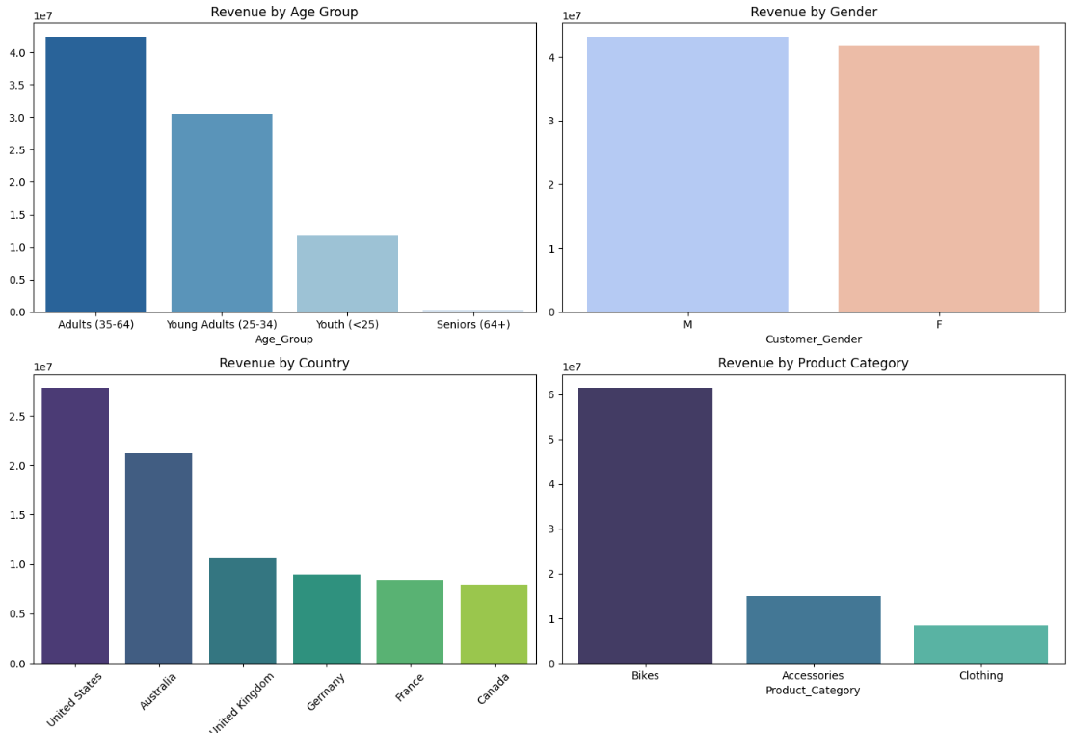

7.Commertial Recommendations

Age Group: Focus marketing on Adults (35–64) and young adults with premium bikes and youth-friendly designs.
Gender: Upsell to male customers with bundles and premium options while running targeted campaigns to grow the female customer base.
Country: Strengthen operations and marketing in the U.S., expand presence in Australia, and explore emerging markets.
Product Category: Prioritize bike production and inventory while cross-selling accessories and apparel to boost revenue.
Seasonality:
- Increase stock and promotions for Winter (peak season), launch Spring campaigns.
- Prioritize Winter Campaigns: Allocate more marketing budget and inventory during Winter to maximize profits.
- Diversify in Off-Seasons: Since Summer and Autumn are weaker, focus on promotions or bundling strategies to boost sales during those periods.

